// Name: ATHAR NOOR MOHAMMD RAFEE

// ID: 20101396 SECTION: 2

// CSE423 LAB1 FALL 2022

// TASK 1

import com.jogamp.opengl.*;

import com.jogamp.opengl.awt.GLCanvas;

import com.jogamp.opengl.glu.GLU;

import javax.swing.*;

import java.util.HashMap;

import java.util.concurrent.ThreadLocalRandom;

class ThirdGLEventListener implements GLEventListener {

*/\*\**

*\* Interface to the GLU library.*

*\*/*

private GLU glu;

*/\*\**

*\* Take care of initialization here.*

*\*/*

public void init(GLAutoDrawable gld) {

GL2 gl = gld.getGL().getGL2();

glu = new GLU();

gl.glClearColor(0.0f, 0.0f, 0.0f, 1.0f);

gl.glViewport(-250, -150, 250, 150);

gl.glMatrixMode(GL2.*GL_PROJECTION*);

gl.glLoadIdentity();

glu.gluOrtho2D(-250.0, 250.0, -150.0, 150.0);

}

*/\*\**

*\* Take care of drawing here.*

*\*/*

public void display(GLAutoDrawable drawable) {

GL2 gl = drawable.getGL().getGL2();

gl.glClear(GL2.*GL_COLOR_BUFFER_BIT*);

/*

* put your code here

*/

gl.glColor3d(1, 0, 0);

gl.glPointSize(8.0f);

gl.glBegin(GL2.*GL_POINTS*);

for (int i = 0; i < 50; i++) {

int x = ThreadLocalRandom.*current*().nextInt(-250, 250);

int y = ThreadLocalRandom.*current*().nextInt(-150, 150);

gl.glVertex2d(x, y);

}

gl.glEnd();

}

public void reshape(GLAutoDrawable drawable, int x, int y, int width,

int height) {

}

public void displayChanged(GLAutoDrawable drawable,

boolean modeChanged, boolean deviceChanged) {

}

public void dispose(GLAutoDrawable arg0) {

}

}

public class Task1 {

public static void main(String[] args) {

//getting the capabilities object of GL2 profile

final GLProfile profile = GLProfile.*get*(GLProfile.*GL2*);

GLCapabilities capabilities = new GLCapabilities(profile);

// The canvas

final GLCanvas glcanvas = new GLCanvas(capabilities);

ThirdGLEventListener b = new ThirdGLEventListener();

glcanvas.addGLEventListener(b);

glcanvas.setSize(400, 400);

//creating frame

final JFrame frame = new JFrame("Lab 1 Task 1");

//adding canvas to frame

frame.add(glcanvas);

frame.setSize(640, 480);

frame.setVisible(true);

}

}

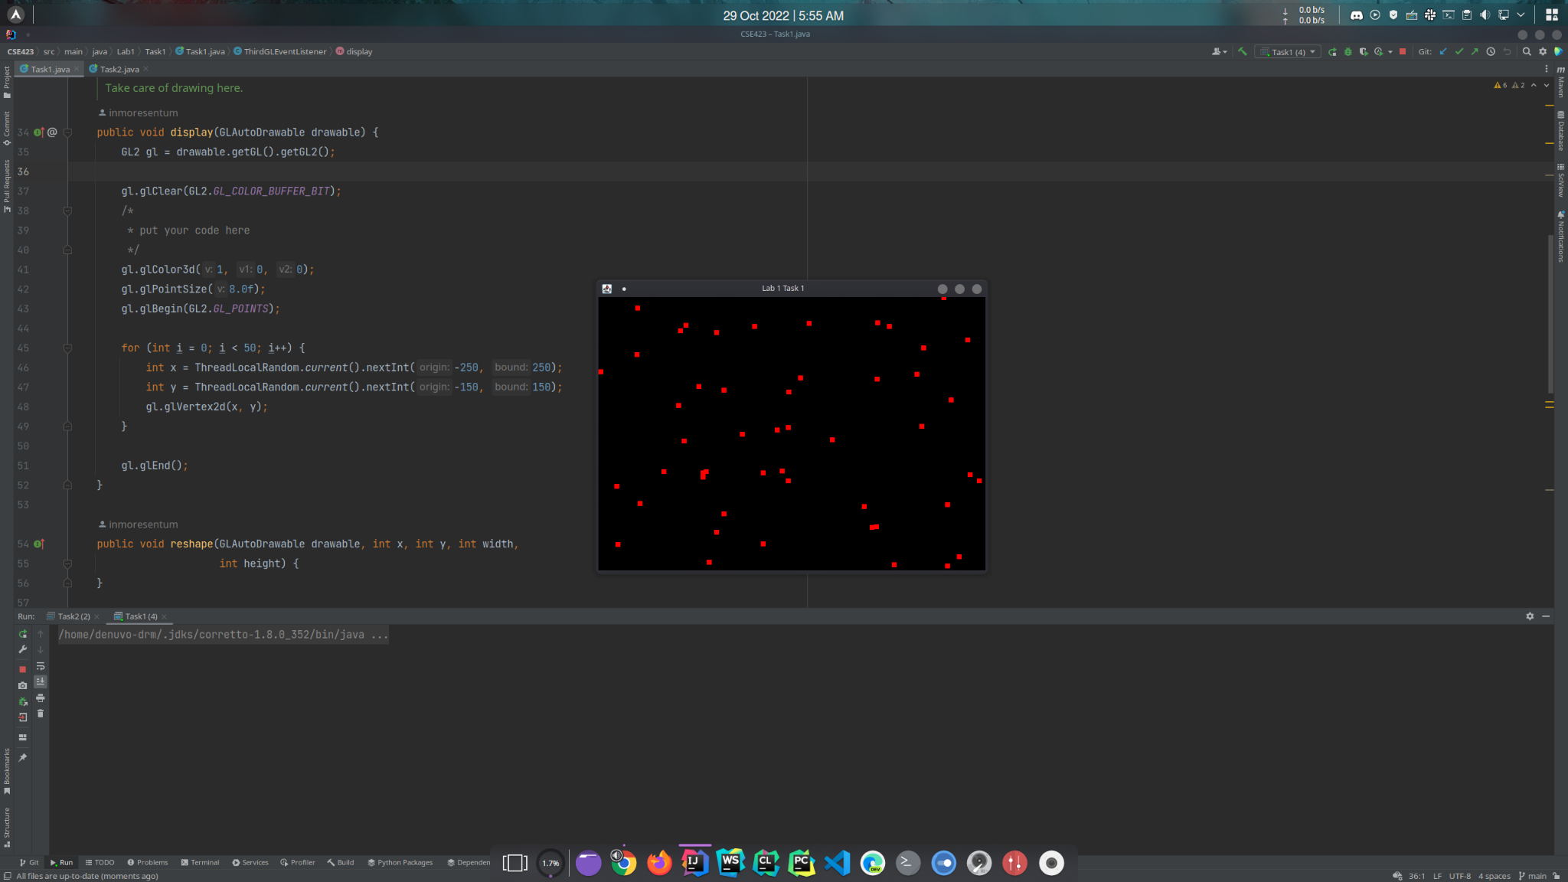

// TASK 2

package Lab1.Task2;

import com.jogamp.opengl.*;

import com.jogamp.opengl.awt.GLCanvas;

import com.jogamp.opengl.glu.GLU;

import javax.swing.*;

class ThirdGLEventListener implements GLEventListener {

*/\*\**

*\* Interface to the GLU library.*

*\*/*

private GLU glu;

*/\*\**

*\* Take care of initialization here.*

*\*/*

public void init(GLAutoDrawable gld) {

GL2 gl = gld.getGL().getGL2();

glu = new GLU();

gl.glClearColor(0.0f, 0.0f, 0.0f, 1.0f);

gl.glViewport(-250, -150, 250, 150);

gl.glMatrixMode(GL2.*GL_PROJECTION*);

gl.glLoadIdentity();

glu.gluOrtho2D(-250.0, 250.0, -150.0, 150.0);

}

*/\*\**

*\* Take care of drawing here.*

*\*/*

public void display(GLAutoDrawable drawable) {

GL2 gl = drawable.getGL().getGL2();

gl.glClear(GL2.*GL_COLOR_BUFFER_BIT*);

/*

* put your code here

*/

gl.glColor3d(1, 1, 1); // r g b

// Size of the point

gl.glPointSize(10.0f);

*drawTriangle*(gl, 0, 100, -100, 0, 100, 0);

// Outer One

*drawRectangle*(gl, 80, 0, -80, 0, -80, -80, 80, -80);

// Inner 1st one

*drawRectangle*(gl, -15, -15, -50, -15, -50, -35, -15, -35);

// Inner 2nd one

*drawRectangle*(gl, 15, -15, 50, -15, 50, -35, 15, -35);

// Inner 3rd One

*drawRectangle*(gl, 15, -45, -15, -45, -15, -75, 15, -75);

// Size of the point

gl.glPointSize(3.0f);

gl.glBegin(GL2.*GL_POINTS*);

// Point on the door

gl.glVertex2d(10, -65);

gl.glEnd();

}

@SuppressWarnings("DuplicatedCode")

private static void drawRectangle(GL2 gl, int x1, int y1, int x2, int y2, int x3, int y3, int x4, int y4) {

gl.glBegin(GL2.*GL_LINES*);

gl.glVertex2d(x1, y1);

gl.glVertex2d(x2, y2);

gl.glVertex2d(x2, y2);

gl.glVertex2d(x3, y3);

gl.glVertex2d(x3, y3);

gl.glVertex2d(x4, y4);

gl.glVertex2d(x4, y4);

gl.glVertex2d(x1, y1);

gl.glEnd();

}

@SuppressWarnings("DuplicatedCode")

private static void drawTriangle(GL2 gl, int x1, int y1, int x2, int y2, int x3, int y3) {

gl.glBegin(GL2.*GL_LINES*);

gl.glVertex2d(x1, y1);

gl.glVertex2d(x2, y2);

gl.glVertex2d(x2, y2);

gl.glVertex2d(x3, y3);

gl.glVertex2d(x3, y3);

gl.glVertex2d(x1, y1);

gl.glEnd();

}

public void reshape(GLAutoDrawable drawable, int x, int y, int width,

int height) {

}

public void displayChanged(GLAutoDrawable drawable,

boolean modeChanged, boolean deviceChanged) {

}

public void dispose(GLAutoDrawable arg0) {

}

}

public class Task2 {

public static void main(String[] args) {

//getting the capabilities object of GL2 profile

final GLProfile profile = GLProfile.*get*(GLProfile.*GL2*);

GLCapabilities capabilities = new GLCapabilities(profile);

// The canvas

final GLCanvas glcanvas = new GLCanvas(capabilities);

ThirdGLEventListener b = new ThirdGLEventListener();

glcanvas.addGLEventListener(b);

glcanvas.setSize(400, 400);

//creating frame

final JFrame frame = new JFrame("Lab 1 Task 2");

//adding canvas to frame

frame.add(glcanvas);

frame.setSize(640, 480);

frame.setVisible(true);

}

}

